###### Assignment Cover Sheet

|  |  |  |
| --- | --- | --- |
| School | SVUCA – Fall 2015 | **SCORE** |
| Module Code | CS502 – Design and Analysis of Algorithms |
| Student ID | 150201133 |
| Student Name | DOAN QUOC SY **VO** |
| Assignment Title/Number | Assignment 1 | |

# Questions

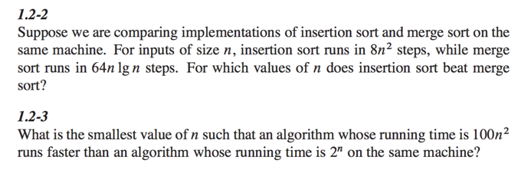

# Answers